**FULL VERSION**

**Sunday 08 – Friday 13 September 2025 – Pelagic trip to Spain and Asturias**

**Day 1: Sunday 8 June**

Sixteen members joined 12 others on the Wessex Continental trip across the Bay of Biscay and into the Picos de Europa. After making our own way to Plymouth Docks our tour guide, Paul Burley was waiting for us. Our birding commenced once we boarded the Brittany Ferries, Pont-Aven for the overnight sailing to Santander. The numbers on deck for sea watching gradually decreased until the last of us went in to eat when it was too dark to see the birds. We were rewarded by several hundred Manx Shearwaters together with Gannets, a surprise flypast by a Little Egret and a single Sunfish looking like a dustbin lid.

**Day 2: Monday 9 June**

From first light a few members were back on deck and the early risers were again rewarded by at least 120 Manx Shearwaters together with a small number of Cory’s Shearwater. Once we were further south a Collared Dove actually landed on the ship for a brief rest and we also started to see Common Dolphins. A few members also saw a Cuvier’s Beaked Whale very close to the ship. Nearer to Santander we started to see Yellow-legged Gulls and Shags on the rocks. After docking in Santander after lunch we boarded the Spanish coach to take us to the hotel in Panes with the drive producing Black Kites and Buzzards. The hotel was right by the River Deva and each day people went for walks before breakfast and in the evenings. Birds seen there were Nuthatch (with youngsters), Short-toed Treecreeper, Common and Black Redstarts and Serin. Often there were Egyptian Vultures circling above and there were also good river birds with Grey and White Wagtails, Dipper and Kingfisher while above were Swifts including one Alpine Swift. In the evening, Paul introduced us to our local guide called Javier, who told us what to expect for the next two days. Photo of whale courtesy of Paul Burley

**Day 3: Tuesday 10 June**

After breakfast we headed through the stunning Hermida Gorge (think Cheddar Gorge on multiple steroids). In Potes we picked up our local guides and continued to Fuente De, where we took the cable car up to the Picos de Europa mountain range. A gentle walk while watching Alpine Chough and 2 Red-billed Chough, Water Pipits reeling and a stunning male Rock Thrush led us to a col where we stopped to search for Snowfinches. Eventually two were found flying around some way above us, clearly going to nest sites, but much better views were had of 2 Alpine Accentors close to the track. From the col a further gentle walk led to the best site for Wallcreeper. After some time a shout of Wallcreeper went up and one flew over us and circled around the nearby crag before quickly flying back down into the boulder field just below the path where it was again seen briefly. On the return walk we had much closer views of Snowfinches with the birds collecting food to take back to the nest sites on the cliffs. Around the top station, there were lots of Alpine Choughs perched and flying around, unafraid of all the people. We then took the cable car back to our waiting coach at Fuente De. At some point during the day a Lammergeier was seen by a few people and this turned out to be the only one seen on the trip.

Photo of Snowfinch flying – Paul Burley

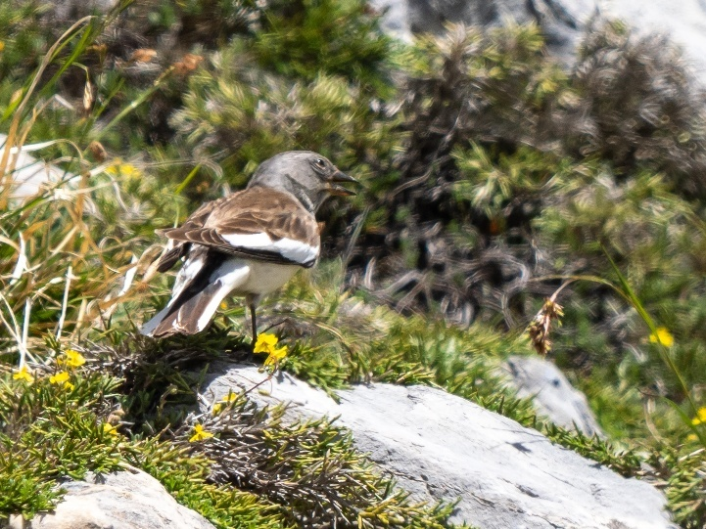

**Day 4: Wednesday 11 June**

Another trip through the Hermida Gorge to Potes was followed by a narrow country road up to Castaños Milenarios above Pendes where a gentle path took us to a good viewpoint to search the rock walls and sky for eagles and vultures. Several Griffon Vultures were cruising around together with a Short-toed Eagle hovering high up in the sky. Meanwhile the vegetation around us held plenty of interest with butterflies galore ( Clouded Yellows, Cleopatra, Lulworth Skippers, Adonis Blues and probably Knapweed Fritillaries) and some excellent birds. The highlight for all of us was the pair of Wryneck with both adults gathering food to take back to the nest hole clearly in sight from the track, but 3 Red-backed Shrike, both Grasshopper and Bonelli’s Warblers and a Blue Rock Thrush feeding a chick were also very satisfactory finds. The pair of Ocellated Lizards were also an impressive sight close to the Wrynecks. A short drive to a stop closer to the rock walls gave slightly closer views of the Eagle together with a Honey Buzzard and a Woodchat Shrike. On the return journey through the Hermida Gorge a male Hen Harrier flew over the coach. Back at the hotel we said our goodbyes to Javier before being entertained by the local bagpipe player while there was a demonstration of how to pour the local cider from a great height, not always successfully.

**Day 5: Thursday 12 June**

On our final morning in Spain, we left the hotel and headed down to the coast at San Vicente de la Barquera for refreshments and an examination of the estuary from the 28 arch Maza Bridge. The tide was low and the birds were scarce, so we had to make do with 3 Spoonbill and a few waders (Curlews and Grey Plover). Then it was on to Santander to catch the ferry. Many of us ate as soon as we boarded so we could spend as long as possible on deck until nightfall. Sightings were limited with Gannets and a few Cory’s Shearwaters (no Manx) but Common and Striped Dolphins were seen.

**Day 6: Friday 13 June**

Braver souls had an early start at 05:00 to get on deck for a sea watch. We saw many Manx Shearwaters along with some Cory’s and 2 Balearic Shearwaters. Also, Common and Striped Dolphins and a distant Minke Whale. Finally on the approaches to Plymouth there were 2 Kittiwakes and a Fulmar. Overall there were 96 bird species seen by the group along with a good selection of butterflies, mammals and other creatures.

Huge thanks to Paul Burley and Javier for guiding, and to Jane for organising the trip. Photos by Keith Williams apart from Cuvier’s Beaked Whale and flight shot of Snowfinch by Paul Burley.

**Keith Williams**